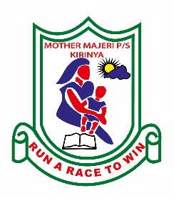MOTHER MAJERI NURSERY SCHOOL

**END OF TERM II EXAMINATION, 2024**

**CLASS : TOP CLASS**

# SUBJECT : READING

**My name is :______________________________________Stream_______**

**1. Sound me well.**

a c z w x s

h d f g k m

**2. Read these sounds.**

sh ue oa oo ck

**3. Read the syllables.**

bo ga fe su ti zo

**4. Read the words.**

bench chalkboard candle

table book snake

**5. Read the sentences.**

He is reading.

I am a boy/girl.

It is a red van.

I can see a book.